Paper Title
THIS IS A BLIND REVIEW. DO NOT INCLUDE AUTHOR INFORMATION!!!
{The extended abstract (or digest) should be a manuscript in single column format with a minimum word count of 400 words and up to FOUR (4) pages in length (note: references may go to the 5th page). The minimum font size is TEN (10) in Times New Roman or Arial type, and the recommended font size is 12. The authors are expected to clearly demonstrate novelty, technical benefits, and conclusive results. To be effective, the authors shall include practical case studies, clear illustrations/figures, and informative discussions on important results. The authors of all accepted extended abstracts/digests shall submit their full manuscripts in IEEE 2-column format and present their papers at the IEEE INTELEC conference during 12-15 Oct. 2025 in Houston, Texas, USA}
Introduction
{This section shall be at least 100 words, explaining the background and motivation}
First Main Section (Proposed Concept, Case Study, etc.)
{This section shall be at least 150 words, with text, equations, and figures. See Fig. 1 for a sample figure. The figure may be positioned appropriately for clarity and space optimization.}
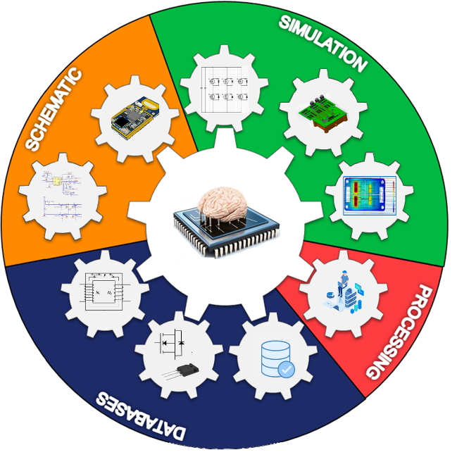
Figure 1: Sample figure.
Second Main Section (Results, Inference, Discussions, etc.)
{This section shall be at least 100 words, with text and figures. The authors may include additional main sections, as necessary.}
Conclusions and Future Work
{This section shall be at least 50 words. State your conclusions here and your plans for the final submission of a full paper, assuming your digest is accepted. Please clearly state your contributions compared with previous work, and list relevant references in the following section. The reviewers will prize effective results/case studies and real-world applications, and as such, please be sure to address these points in your extended abstract/digest.}
References
{Note: references are required. This section is not included in the four-page limit. References can be single-spaced. See example below.}
[1] J. Doe, J.F. Stevens and B. Smith, “Title of their journal paper,” Journal Title, vol. 17, no. 1, pp. 123-133, Feb. 2005.
[2] J. Doe, J.F. Stevens and B. Smith,, “Title of their conference paper,” in IEEE 1997 Conference Name, 2017, pp. 122-129.
[3] A.C. Doyle, Title of book, Publisher’s Name, City, 2020.

